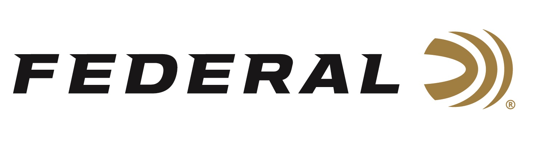

FOR IMMEDIATE RELEASE

Federal Ammunition Shooters Shine at the Grand American

ANOKA, Minnesota – September 1, 2021– Sparta was simply spectacular this year for several of Federal’s sponsored shooters who claimed dozens of awards during the 11-day event. Held at The World Shooting and Recreational Complex in Sparta, Illinios since 2006, the event is the largest of its kind and draws an expansive field of shooters, including an international contingent.

“This event showcased several great performances from our talented team of shooters,” stated Jason Nash, Federal Ammunition’s Vice President of Marketing. “They endured a demanding event and posted impressive scores that Federal is proud of and celebrates.”

Federal sponsored shooters Stacey Rehor, Lauren Dunn, Debbie Ohye Neilson, and Payton DeTavernier dominated the Lady I and Lady II divisions. Rehor won seven event championships and eighteen total awards and was the only shooter in singles to break 500X500 targets during the preliminary week. She won the Prelim HOA and the ATA HOA designations capping off a stellar performance in Sparta. Dunn won the prestigious ATA Doubles Championship sponsored by Federal. Rising star DeTavernier took home ten awards following the competition including third in ATA All-Around and Runner-up in ATA HOA 1000. DeTavernier, a student at Doane College in Nebraska, had her personal best performance in singles breaking 898 of 900 targets. She won two event championships and in the Super 500 Singles, she broke 499 of 500 targets. Ohye Neilson won twenty-three awards in the Lady II division. She dominated the field with seventeen event championships.

Teen sensation Grayson Stuart also shined at this year’s Grand American. The Utah native broke a 100 straight from 27 yards to win the Jr. Champ crown. Others taking home accolades from the Grand American included Ray Stafford, winning two events including the Super 500 Singles. Austin Jacobs was a champion in four events including events 14, 19, and 22 which were doubles, Handicap 27yards, and Doubles ATA. Tank Lunsford was the runner-up in the ATA Doubles Sub-Vet and Aaron Willoughby finished third in the Handicap event. Rounding out some great performances from Team Federal was South Dakota’s Tim Reed. He finished third in the AAA Prelim HOA.

For full results, go to https://scores.shootata.com/shoot.

For more information on all products from Federal or to shop online, visit
www.federalpremium.com.

Press Release Contact: JJ Reich
Senior Manager – Press Relations
E-mail: VistaPressroom@VistaOutdoor.com

About Federal Ammunition
Federal, headquartered in Anoka, MN, is a brand of Vista Outdoor Inc., an outdoor sports and recreation company. From humble beginnings nestled among the lakes and woods of Minnesota, Federal Ammunition has evolved into one of the world's largest producers of sporting ammunition. Beginning in 1922, founding president, Charles L. Horn, paved the way for our success. Today, Federal carries on Horn's vision for quality products and service with the next generation of outdoorsmen and women. We maintain our position as experts in the science of ammunition production. Every day we manufacture products to enhance our customers' shooting experience while partnering with the conservation organizations that protect and support our outdoor heritage. We offer thousands of options in our Federal Premium and Federal® lines-it's what makes us the most complete ammunition company in the business and provides our customers with a choice no matter their pursuit.

